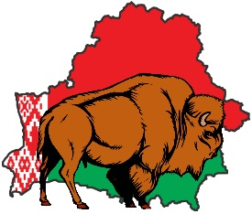
7th International 29.11 – 04.12.2017 1st Open team
Martial Arts Games Minsk, Republic of Belarus World Cup WKC

www.imgc-99.org

ACCOMMODATION FORM

Country:
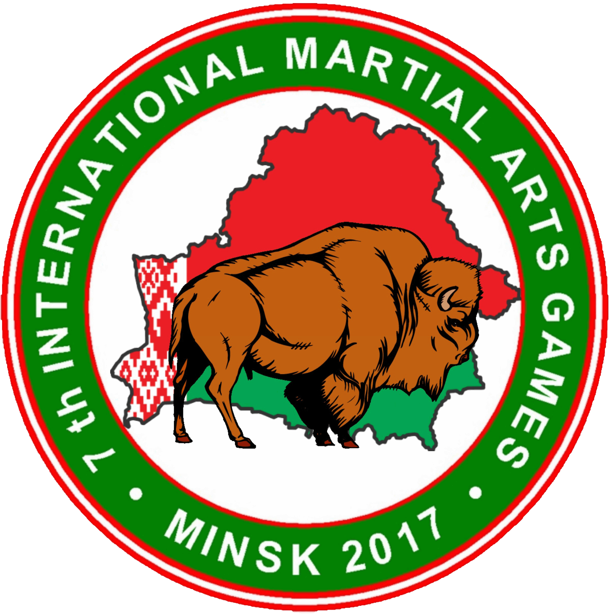
Club/Federation:
Contacts (e-mail, tel.):
Representative

№ | Surname | Name | Sex  Male/Female | Title | Arrival | Departure | Room  (single, double, twin) | Package  (A, B, C)

Accommodation Form must be sent to the Organizing Committee BEFORE or on the deadline of 15.11.2017
by e-mail: iamg2017@mail.ru

7th International 29.11 – 04.12.2017 1st Open team
Martial Arts Games Minsk, Republic of Belarus World Cup WKC

www.imgc-99.org

Visa application

Country:
Club/Federation:
Contacts (e-mail, tel.):

№ | Surname | Name | Sex | Date of birth | Number of pasport | Date of issue,  Date of expiry | Сitizenship | The country  of permanent  residence | Status

Accommodation Form must be sent to the Organizing Committee BEFORE or on the deadline of 15.10.2017
by e-mail: iamg2017@mail.ru

