Czech Karate Federation
Pilsen Karate Federation



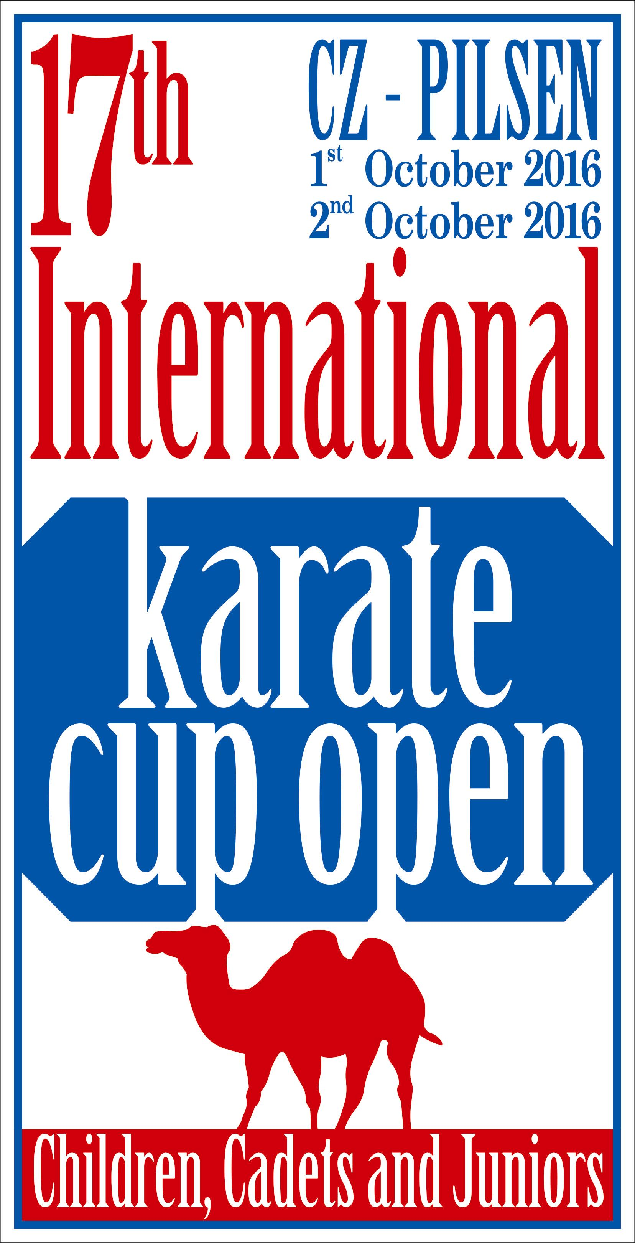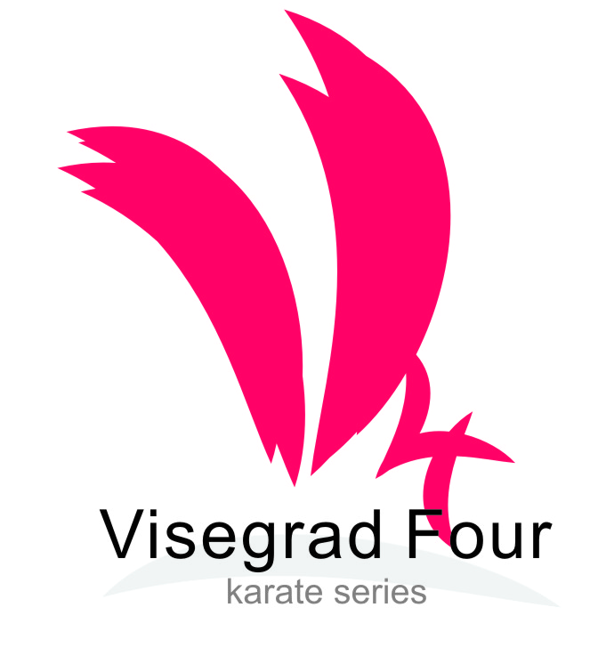

The 17th
Czech Karate Open
Euro Grand Prix
Visegrad four series

For Children, Youth and Seniors

1st – 2nd October, 2016
Pilsen (Plzeň)
Czech Republic
City Sports Hall, Úslavská street

Dear Friends,
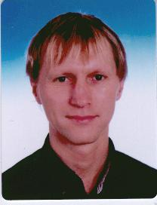
We would like to invite you to the biggest international tournament in karate for youth and adults, which is held in the Czech Republic.
The tournament, which launched its own history at the turn of the millennium in 2000 , found in the last years of European and world elite and became highly sought after preparatory tournament for many federations.

We are very happy to welcome family karate from around the world that will host one of the great sports towns in the Czech Republic. City of Pilsen trained many famous athletes and stars not only karate , but from a very wide field of sports .
We are proud that the tournament has been held for the seventeenth time , when this year the city of Pilsen , was last year the European City of Culture. A right combination of sport and culture, and of course a good drink is our biggest draw for all participants in this tournament .
Once again, therefore we would like to invite you to this event and look forward to your participation.
Sincerely,

Marek Kubin
Chairman of Organizing committee

Words of the ViceMayor of the City of Pilsen on the 17th Karate Euro Grand Prix

It is an honour for the City of Pilsen to host a prestigious competition of young karate fighters Euro Grand Prix.
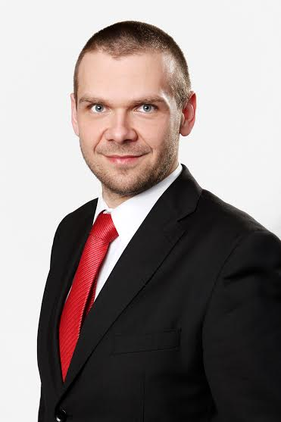

Although I cannot master karate I am aware that this old Asian martial art is a demanding and attractive sport discipline and it is pleasing that a lot of young people go in for it. I think that young people learn discipline, tenacity, fast reactions and movement abilities when doing karate. If it is used and trained according to methods of ancient Japan martial art masters it leads to creating of character, to strengthening of self-restraint and to responsibility. It is a kind of sport which develops physical and intellectual qualities.

I wish the Pilsen tournament every success, very good and fascinating performances, great public interest and a largest possible number of participants who I greet sincerely in our city.

Jime.

Mgr. Martin Baxa
ViceMayor of the City of Pilsen

Dear athletes, coaches, referees and supporters karate,
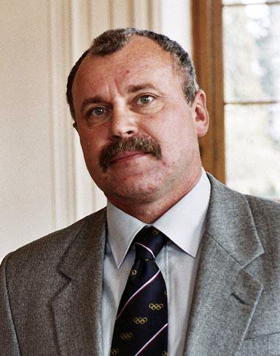
Let me add my invitation to the traditional karate tournament for youth in Pilsen.
Our Foundation has for many years supported the growth not only of your sport, but a lot of other sports, they work well as enthusiasm for the future, ie with children and youth.

It is symbolic that Pilsen, which has in its ranks a wide range of athletes at all levels, supports just your sport, which is probably best known for Pilsen natiwe Petra Nova .
Therefore, I would like to wish the organizers of the nerves and calm the athletes success enthusiasm and vigor, coaches a good strategy and impartiality of the judges and a sharp eye.
Good luck

Mgr. Frantisek Berka
Chairman of the Board of Youth sport foundation

Competition place

City sporthall (Lokomotiva) Pilsen

Úslavská str.

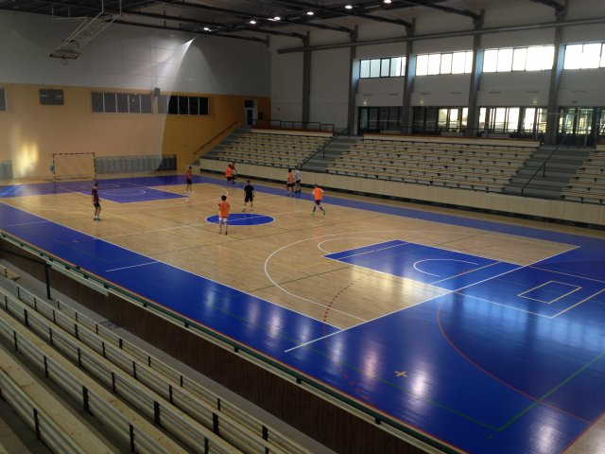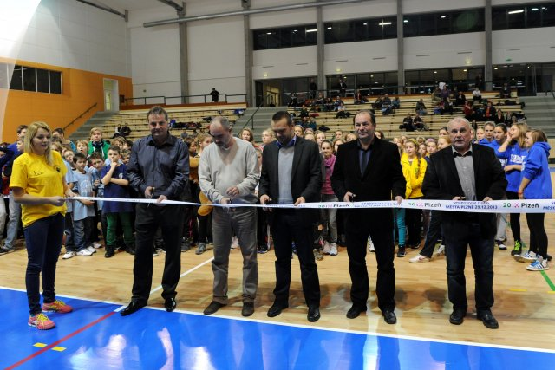

Sporthall after reconstruction now is in full function. Here is on Youtube all visit opening ceremonial.

Here is map another places on the sporthall informations

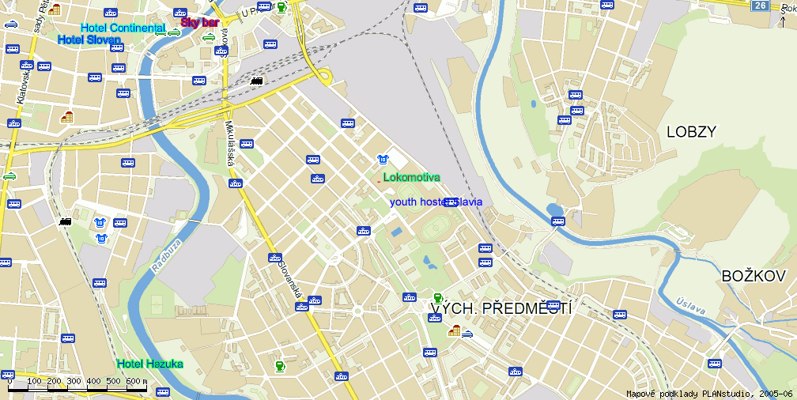

Categories

Saturday 1st October 2016

Cadets, U21, seniors

Cadets Kata Cadet female, male
14-15 years Kumite cadet female -47, -54, +54kg
Kumite cadet male -52, -57, -63, -70, +70kg

U21 Kata female, male
18-20 years Kumite female -53, -60, +60kg
Kumite male -65, -78, +78kg

Seniors Kata female (up 16 years)
18 and older Kata male (up 16 years)
Kumite female -50, -55, -61, -68, +68kg

Kumite male -60, -67, -75, -84, +84kg

Sunday 2nd October 2016

Juniors, children

Juniors Kata junior female, male
16-17years Kumite junior female -48, -53, -59, +59kg
Kumite junior male -55, -61, -68, -76, +76kg

Children
9-11 years Kata girls, boys
Kumite girls -35, +35kg
Kumite boys -32, -40, +40kg

12-13 years Kata girls, boys
Kumite girls -50, +50kg
Kumite boys -45, -55, +55kg

Rules

New competition rules WKF(1.1.2015) and changes from this bulletin.

Kata

Children 9-11 years Tokui kata by WKF rules, one time repeated kata any round
Both competitors practicing together. Medal both and semifinal separatly.

Children 12-13 years Tokui kata by WKF rules, each round diferently kata.
Both competitors practicing together. Medal both and semifinal separatly..

Cadets, juniors, U21, seniors – tokui kata by WKF rules without changes (1.1.2015).

Kumite

Children

9-11 years time competiton match 90 sec., tatami 6*6 meters
WKF rules for category cadets

12-13 years time competiton match 90 sec., tatami 8*8 meters
WKF rules for category cadets

Cadets, juniors, U21, seniors - WKF rules (1.1.2015)

Equipments

Obligatory equipments for all categories (approved type WKF,EKF or national federation)
- Gum shields
- Shin protectors blue and red
- Food protector blue and red
- Hand protector blue and red
- Body protector
Categories girls and female - Chest protector (obligatory together with body protector)

Non obligatory, but accepted for categories 12-13 years and cadets
- Facemask approved WKF
- Suspenzor (all men categories)

They can start on two age categories is possible, but here is special system for this:

Children 9-11 years children 12-13 years only kata

Children 12-13 years cadet kata+ kumite
Cadet Junior kata + kumite
Junior U21 kata + kumite
U21 Senior no restriction

Another start isn´t possible.
Start in kata only two categories. Don´t possible start from 16 years all categories.

Payment entry fee is per competitor and category. No sales ,no cumulations.

All changes and start you must on registration by www.sportdata.org. Any changes after stop will be payment to extra money 10 Euro per entries.

Any manipulation of date of birthday is prohibited!! If it is found to be disqualified before, durind and after the tournament. Including the possibility of futher sanctions in future editions tournaments.

All categories can be changes by organizer by full the competition.
Date for category is date tournament it´s 2nd October 2016.

Entry fee:
20 Euro per competitor and category

Bank trasfer:
Bank account nr: 2300984207
IBAN: CZ6620100000002300984207
BIC/SWIFT: FIOBCZPPXXX
Name: Club karate Plzen z.s.
Fio banka a.s., Millennium Plaza, V Celnici 10, Praha 1,11721

Paypal directly from website www.sportdata.org
This payment prefer for individuals payment max. 20 entries

Partcipants:

All european and world clubs

Entries:

On-line by website www.sportdata.org. No later then 25th September 2016.

Maximum is 1000 entries.

If the limit is filled before the system will only accept the waiting list and everyone will be informed by the organizers that will be accepted into the tournament.

Payment of fee may directly transfer the amount to the bank account in advance or on the spot with the fee payment in cash.

The team will pay on the spot cash for all competitors have registered. Failure to do so will not be admitted to the tournament. Credit transfer, this rule does not apply.

For payment in cash paid on Saturday or Sunday before the tournament and no later than 11.00 (min. one hour before the start of the categories in the case of earlier start than in the 11th hour). If in this period, the entry fee will be paid athlete removed from the start list, although it is already paired .

Referees : Referee and judges will invite organizer by VIP invitation letter

Tournament schedule

Friday 30th September 2016

17⁰⁰ technical meeting internat. teams(clubs from Czech are welcome)
Hotel Hazuka
Only for payment and changes. Paricipate only head of delegation or clubs

17⁰⁰ - 19⁰⁰ registration competitors

Saturday 1st October 2016

9⁰⁰ opening tournament
9⁰⁰ - 11⁰⁰ elimination kata cadets, U21 a seniors

11⁰⁰ - 16³⁰ elimination kumite cadets, U21 a seniors
18⁰⁰ - 18³⁰ Opening ceremonial

18³⁰ - 20⁰⁰ Final category senior

Sunday 2nd October 2016

9⁰⁰ opening tournament
9⁰⁰ - 11³⁰ elimination kata children, juniors
12⁰⁰ - 16⁰⁰ elimination kumite children, juniors

16³⁰- 17⁰⁰ Ceremonial closing tournament

Time schedule by tatami by categories and all time informations, will be 2 days before start tournament after finishing registration.

Every this will be on www.sportdata.org or web site tournament.

Accomodation:

 | Accomodation 17.^{th} EGP 1.-2.10.2016
Name of hotel | Stars | Nr. rooms |  |  | single | double |  | Triple | breakfest | Information
Hotel Primavera | **** | 89 |  |  | 44 Euro | 56 Euro |  | 72 Euro | Include | Hotel Primavera
Parkhotel Plzen | **** | 150 |  | 50 Euro |  |  | 65 Euro | 80 Euro | Include | Parkhotel Plzen
Hotel Hazuka | *** | 35 |  |  | 44 Euro | 56 Euro |  | 72 Euro | Include | Hotel Hazuka
Hotel Victoria | *** | 58 |  |  | 35 Euro | 50 Euro |  | 65 Euro | Include | Hotel Victoria
Hotel Ibis | *** | 80 |  |  | 35 Euro | 50 Euro |  | On question | Include | Hotel Ibis

If all hotels will be full next accomodation:
Hotel Central | *** | 77 |  | 35 Euro | 50 Euro | 65 Euro | Include | Hotel Central

Prices per room and night

Headquarter hotel

Hotel Hazuka ***
Zborovská 8
Pilsen

Contakt tel.: 377420010
Mob: 603255520
Mail: info@hotelhazuka.cz
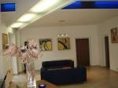

Next information is on hotel web site www.hotelhazuka.cz

On booking by mail or calling password karate. Prices another companies or booking don´t garancy.
Next partners hotel:

Hotel Primavera & congres centre ****
Nepomucká 1058/128
Pilsen

Contakt tel. 378020500
Mob. 603113853
Mail info@primaverahotel.cz
Web: www.primaverahotel.cz

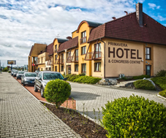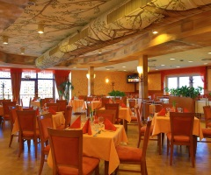

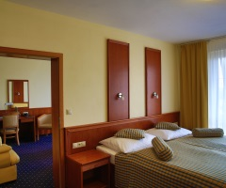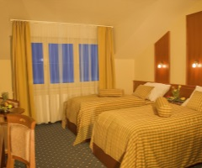

Hotel Victoria ***
Borská 19
Pilsen

Contakt tel. 377221010
Mail info@hotel-victoria.cz
Web www.hotel-victoria.cz
GPS 49°44´23.064´´N, 13°22´7.82´´E

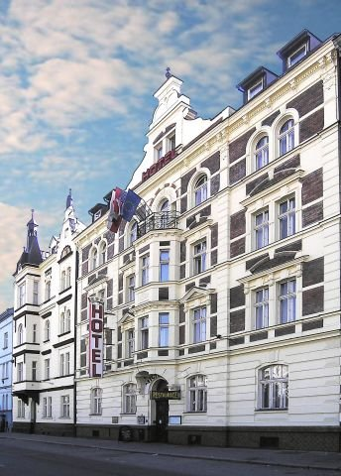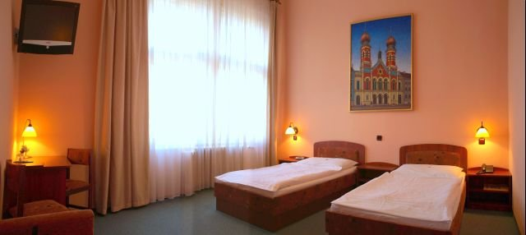

Hotel Ibis ***
Universitni 65
Pilsen

Contakt tel. 377887777
Mail h6734@accor.com
Web. www.hotelibisplzen.cz
GPS GPS: N 49° 43' 31.00'' E 13° 19' 38.42''

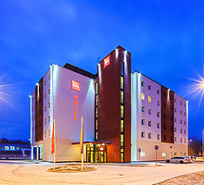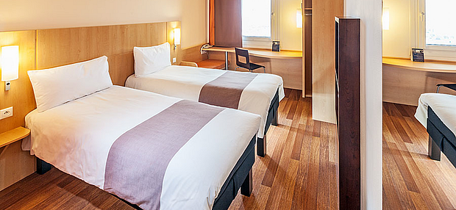
Parkhotel Plzeň ****
U Borského parku 31
Pilsen

Contakt tel. 378772977
Mob 608111702
Mail hotel@parkhotel-czech.eu
Web www.parkhotel-czech.eu

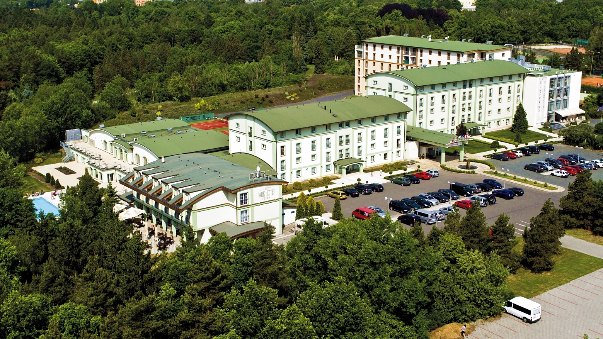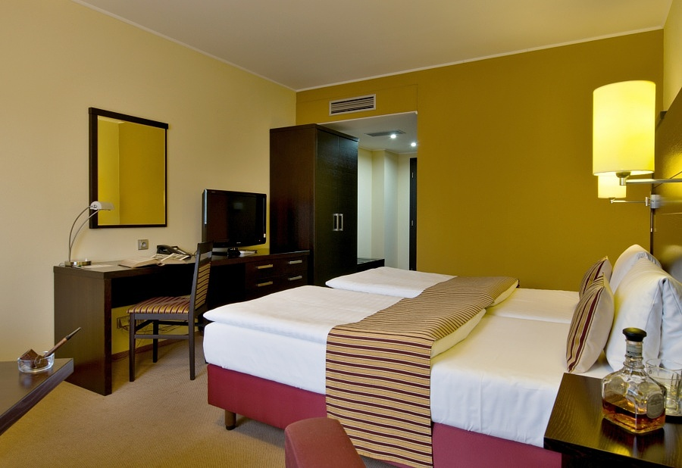

If will be full this partners hotel, can will book on this hotels:

Hotel Central ***
Náměstí Republiky 33
Pilsen

Contakt tel. 377226757
Mail hotel-central@zkdplzen.cz
Web www.central-hotel.cz

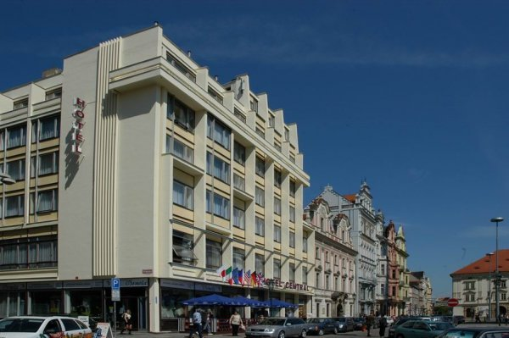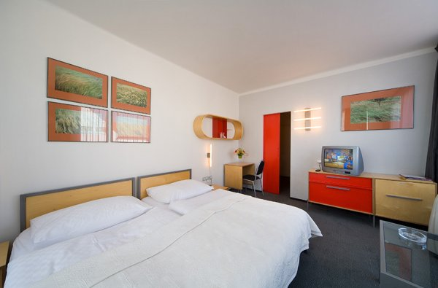

Booking are all hotel garanted prices and password is „karate“ .

Transport

We transport our teams from the airport Vaclav Havel in Prague in the official hotels and back for a fee of 20 Euro per person.
To ensure transport is necessary to fill the table below.

Date arrival | Time arrival | Nr. flight | Company | destination | Nr. person | leader | country | hotel | terminal | Date departure | Time departure

Transport from the official hotels to the sports hall is free for the duration of the tournament and will be provided throughout the day at hourly or two-hourly intervals.
More detailed timetable will be published on the website of the tournament, the registrar www.sportdata.org and in all the partner and the official hotels.
All buses, minibuses or cars will carry the logo of the tournament

Maps with places sport hall and partners hotels
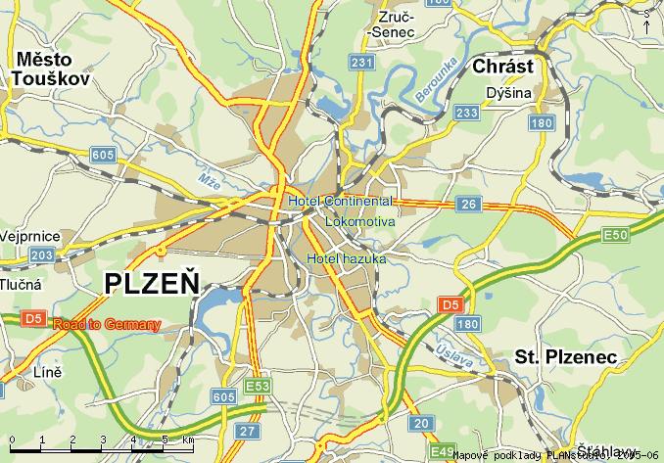

Marek Kubín Jan Pytlík
Organizing Commission president
of The Pilsen Karate Federation
e-mail: kubin@karatecz.cz e-mail: pytlik@karatecz.cz

