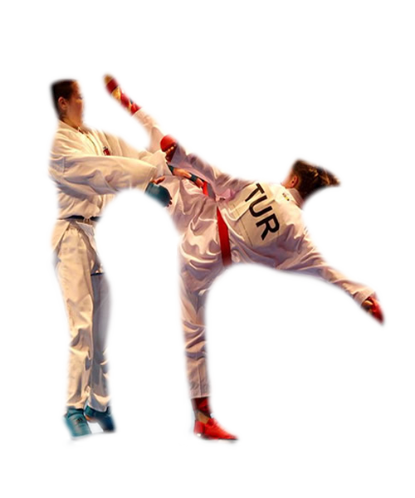


Categories (Kumite Shobu, WKF, Karate Contact)

Of Open Karate Tournament will be held in the Trabzon Of on the dates of -2 December 2012.

Registrations

Children Male 7 Years Kata 15kg 20kg 25kg +25kg
Children Female 7 Years Kata 15kg 20kg 25kg +25kg
Children Male 8 Years Kata 20kg 25kg 30kg +30kg
Children Female 8 Years Kata 20kg 25kg 30kg +30kg
Children Male 9 Years Kata 25kg 30kg 35kg +35kg
Children Female 9 Years Kata 20kg 25kg 30kg +30kg
Cadets Male 10 Years Kata 30kg 35kg 40kg +40kg
Cadets Female 10 Years Kata 25kg 30kg 35kg +35kg
CadetsMale 11 Years Kata 35kg 40kg 45kg +45kg
CadetsFemale 11 Years Kata 30kg 35kg 40kg +40kg
CadetsMale 12 Years Kata 40kg 45kg 50kg +50kg
Cadets Female 12 Years Kata 35kg 40kg 45kg +45kg
Cadets Male 13 Years Kata 40kg 45kg 50kg +50kg
CadetsFemale 13 Years Kata 35kg 40kg 45kg +45kg
Cadets Male 14‐15 Years Kata 52kg 57kg 63kg 70kg +70kg
Cadets Female 14‐15 Years Kata 47kg 54kg +54kg
Juniors Male 16‐17 Years Kata 55kg 61kg 68kg 76kg +76kg
Juniors Female 16‐17 Years Kata 48kg 53kg 59kg +59kg
Seniors Male 18 and Over Kata 60kg 67kg 75kg 84kg +84kg
Seniors Female 18 and Over Kata 50kg 55kg 61kg 68kg +68kg
Children Male 7-9 Years Team Kata - Kumite
Children Male 10-11 Years Team Kata - Team Kumite
Children Male 12-13 Years Team Kata - Team Kumite
Cadets Male 14-15 Years Team Kata - Team Kumite
Junior Male 16-17 Years Team Kata - Team Kumite
Senir Male 18 and Over Team Kata - Team Kumite

Registration forms must be submitted to the turkishkarate@gmail.com adress..

Programme
30 November 2012 Friday
- 12:00 - 18:00 Registrations
- 18:00 - 20:00 Drawing

1 December 2012 Saturday
- 09:00 – 12:00 Children Cadets Male and Female
Kata and Kumite Ind. and Team
- 12:00- 14:00 Lunch Break
- 13:30 – 19:30 Cadets Male and Female
Kata and Kumite Ind. and Team
- 19:30 Finals

2 December 2012 Sunday
- 08:30-12:30 Junior and Senior Ind.and Team
Kata Kumite
- 12:30-13:30 Lunch Break
- 13:30- 19:30 Juniors Seniors
Individual and Team
- 19:30 Finals

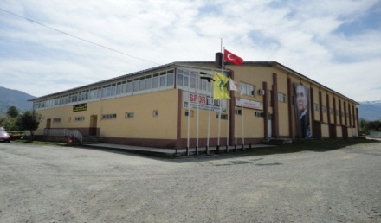

Teknik Talimat

- Müsabakalar W.K.F. kurallarına göre yapılacaktır.
- Müsabaka Kayıtları online olarak www.sportdata.org internet sitesinden yapılacaktır.
- Bu Talimatla ilgili gerekli değişikliklerde karar verme yetkisi W.S.K.U. Türkiye Organizasyon Kuruluna aittir.

Entry Fee's

Children Categories 25 USD
Cadets, Junior and Senior Categories 30 USD
Team Categories 60 USD

Of Stadium Of-Trabzon
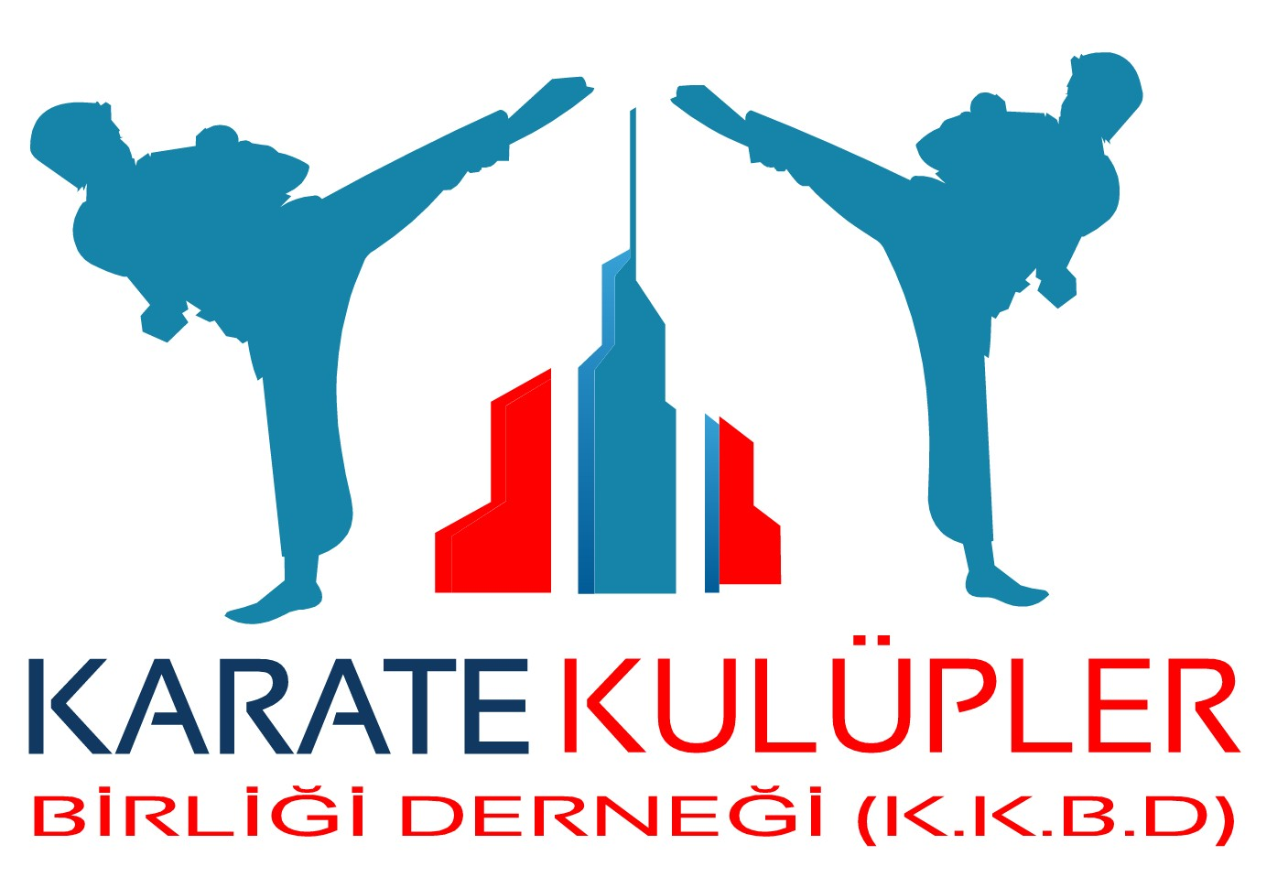

REGISTRATION FORMS

Name Surname | Country | Category | Weight
turkishkarate@gmail.com

