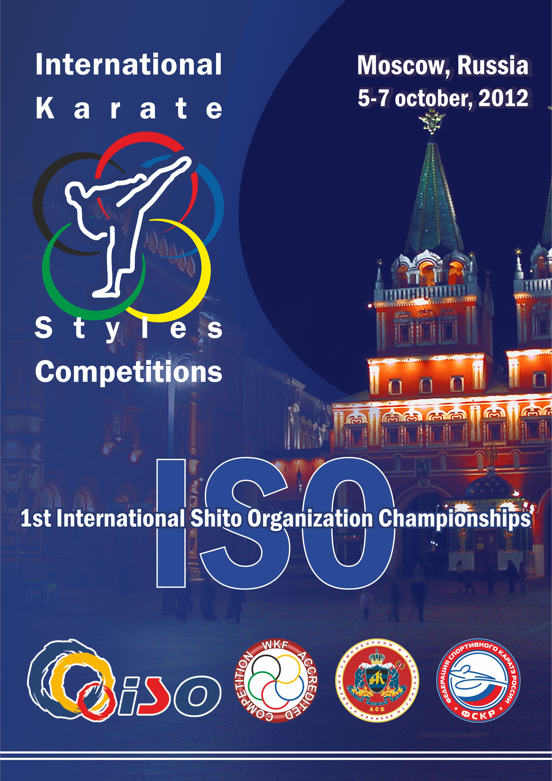

Date : 5-6-7 October 2012
Categories : Individual WKF Kumite Male and Female
Individual and team Kata Shito Ryu
Rule : WKF Rules will be applied in WKF Categories
Registrations : Registrations must be made online on
https://www.sportdata.org/karate/wac/veranstaltung_info_main.php?active_menu=calendar&vernr=814

until October, 1st, 2012.

How to register online:
For registration you need a team / club account.
For users having a team / club account, please re-use your account . In this case you can also re-use all competitors, coaches, referees and officials data you already entered.
If you have forgotten or lost your account data, please contact our team. We will reset the password and send you Username and new Password.
For teams that have no account yet, please register online and create a new account team / club account.
For registration of competitors, coaches, referees and officials please do the following steps:
- Log in with your account
- Check your team data. Please check if the data is correct and up to date
- Enter or change the data of your competitors, coaches, referees and officials. Upload a picture for all participants you want to register.
- In the event calendar go to the event you want to register for, Click on the “Registration” button of the event.
- On the bottom of the entries site you will see the functions to make new entries
- Register your competitors / teams in categories, coaches, referees and officials

If you have any questions please check the online help and video tutorials: https://www.sportdata.org/karate/set-online/faq_en.php?active_menu=faq or contact our the Sportdata team.

The official registration session will be held on 4-5 October 2012 from 10.00 am to 20.00 pm in the Sports Palace «Dynamo». One official from each team must show up at the official registration held on Thursday and Friday before the event to verify / purchase the WKF ID cards of all team members. This official person has to register the complete team. To speed up the registration and ID card process it is possible for individuals to register.

Please also note that this event is an official WKF Accredited Styles event. Teams not registered at the official registration can not participate. All teams with athletes participating on Friday, have to register on Thursday. All teams with athletes only participating on Saturday and Sunday, have to register latest on Friday.

Protective Equipment: All equipments must be WKF approved. Gumshields,
Handgloves, Foot and Shin Protect is compulsory in WKF
Competitions.

The rules are the WKF rules and it is obligatory all children and cadets-juniors categories to have the WKF face mask and the WKF approved items.

Insurance : All participants must arrange their own insurance in the time
period of the event.

Location of Event : Palace of Sports «Dynamo» www.dsdynamo.ru

Organizing Committee
Sport Karate Federation of Russia
Public relations director: Natalia Tishchenko
Tel: +7 (495) 66 111 22
E-mail: academiaasb@gmail.com
Web-site: http://academia-asb.ru/

International Shito Organization
General Secretary: Mr. Rajko Vujosevic
E-mail: info@iso-karate.net
Entry Fee:

The entry fee for the participation is 30 € per person per category. As for all WKF events, all team members need a valid WKF ID card. This includes competitors, coaches, referees and officials (27 €, cost). Children ID card (karate kid ID) will cost 10 €. All incomes of the ID belong to WKF as the event is a WKF accredited competition (WAC).

CATEGORIES

Individual Kata
Category | Ages | Section
Children Male | 2004 | Kata
Children Female | 2004 | Kata
Children Male | 2003 | Kata
Children Female | 2003 | Kata
Children Male | 2002 | Kata
Children Female | 2002 | Kata
Children Male | 2001 | Kata
Children Female | 2001 | Kata
Children Male | 2000 | Kata
Children Female | 2000 | Kata
Children Male | 1999 | Kata
Children Female | 1999 | Kata
Cadets Male | 1998-1997 | Kata
Cadets Female | 1998-1997 | Kata
Junior Male | 1996-1995 | Kata
Junior Female | 1996-1995 | Kata
Senior Male | +16 years | Kata
Senior Female | +16 years | Kata

Individual Kumite
2004 Year Male Kumite | 25 | 30 | 35 | 40 | 45 | +45
2004 Year Female Kumite | 30 | 35 | +35
2003 Year Male Kumite | 30 | 35 | 40 | 45 | 50 | +50
2003 Year Female Kumite | 30 | 35 | +35
2002 Year Male Kumite | 30 | 35 | 40 | 45 | +45
2002 Year Female Kumite | 35 | 40 | +40
2001 Year Male Kumite | 35 | 40 | 45 | 50 | +50
2001 Year Female Kumite | 37 | 42 | +42
2000 Year Male Kumite | 40 | 45 | 50 | 55 | +55
2000 Year Female Kumite | 42 | 47 | +47
1999 Year Male Kumite | 52 | 57 | 63 | 70 | +70
1999 Year Female Kumite | 47 | 54 | +54
1998-1997 Years Male Kumite | 52 | 57 | 63 | 70 | +70
1998-1997 Years Female Kumite | 47 | 54 | +54
1996-1995 Years Male Kumite | 55 | 61 | 68 | 76 | +76
1996-1995 Years Female Kumite | 48 | 53 | 59 | +59
+18 Male Kumite | 60 | 67 | 75 | 84 | +84
+18 Female Kumite | 50 | 55 | 61 | 68 | +68

Team Kata
Category | Ages | Section
Children Male | 10-13 years | Kata
Children Female | 10-13 years | Kata
Cadet/Junior Male | 14-17 years | Kata
Cadet/Junior Female | 14-17 years | Kata
Senior Male | +16 years | Kata
Senior Female | +16 years | Kata

Team Kumite

Category | Ages | Section
Children Male | 10-13 years | Kumite
Children Female | 10-13 years | Kumite
Cadet/Junior Male | 14-17 years | Kumite
Cadet/Junior Female | 14-17 years | Kumite
Senior Male | +18 years | Kumite
Senior Female | +18 years | Kumite

REFEREE COURSE
Moscow 4 October 2012
Sports Palace «Dynamo»

Referee Course will be provided by Sergey Sokolovski, President of Karate Federation of Russia, WKF / EKF Kumite Referee A, EKF Kata Judge A, WKF Kata Judge B.

Languages: English, Russian.

Referee Course Program:

10.00 - Registration
11.00 – Theory Course (KUMITE, KATA)
15.00 – Theory Examination

PROGRAMME OF COMPETITIONS
Friday 5 October 2012
09:00 All Kata categories
Saturday 6 October 2012
14:00 Open Ceremony
Sunday 7 October 2012
09:00 All Kumite WKF categories

- The final version competition Programme will be available one day before the tournament according to the number of participants
- Every competitor in Kata categories will present a maximum of five (5) different kata (2 shitei and 3 tokui)

Accommodation
For accommodation in the Russian Federation of foreign delegations numerous hotels of Moscow with different level of price and quality can be used. Booking of the accommodation in advance is strongly recommended.

Recommended Hotels:
- Hotel "Soyuz": str Levoberezhnaya,12, metro Rechnoy Vokzal (time to the Palace of Sports 20 minutes) Cost: $ 140 standard Twin, 140 $ Singl (with breakfast).
- Hotel "Aeropolis": Leningradskiy Prospect, 37, korp.5, metro "Aeroport", (time to the Palace of Sports 30 minutes), Price: $ 140 standard Twin, 90 $ Singl (with breakfast).
- "VashOtel":
- "VashOtel-Kuzminki" Kuzminki (time to the Palace of Sports 1 hour), Cost: $ 60 pers. / Per night (including breakfast),
- "VashOtel-Sayan," VDNH (time to the Palace of Sports 1 hour), cost $ 40 pers. / per night (including breakfast),
- "VashOtel-Rise" Vladykino pm (time to the Palace of Sports 1 hour), the cost of $ 56 pers. / per night (with breakfast).

Booking for these hotels must be made until September 24.
To book hotels "Aeropolis" and "VashOtel" contact "TranstourTravel":
Natalia Averina, averina@transtour.ru

Transfer
Prices for transfer between airport-hotel-airport: 315 $ (for a bus with 1-19 persons); 570 $ (for a bus with 20-40 persons).

Any help concerning tickets, transfer and hotels is provided by the travel agency “TRANSTOUR TRAVEL LLC”:
Ticket Booking: Elena Lukina lukina@transtour.ru
Hotel Booking and Transfer Service: Natalia Averina averina@transtour.ru

