Tani-ha Shito-ryu Kofukan Karate World Cup Moscow 2011
Outline of events
- Tournament organizer : International Federation Tani-ha Shito-ryu Karate-do Kofukan Federation, Tani-ha Shito-ryu Karate-do Kofukan Russia.

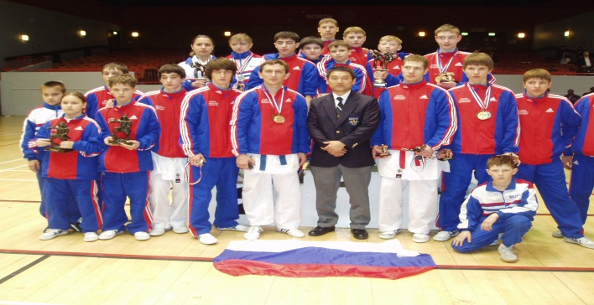
- Venue : CSKA Palace of Martial Arts, 39 Leningrad Avenue, Moscow

- Date : April 16-17th, 2011

- Main timetable, regulations and rules of tournament
On April 15th 2010 19-00 in the evening : Delegates’ Meeting

Timetable:
Note :- Age and weight categories - according to Kofukan International rules (see below)

16 April Saturday Senior Events (16 year +)

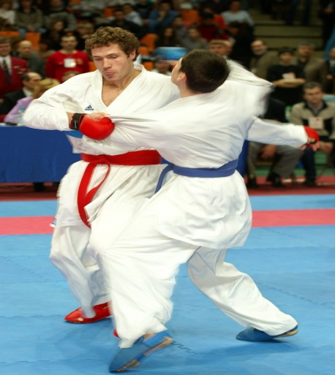
Kata – Team
Female Kata – Individual
Male Kata – Individual

Female Kumite – Team (3 + 1)
Male Kumite – Team (5 + 2)
Female Kumite - under 60 kg
Female Kumite - Over 60 kg
Male Kumite - Under 68 kg
Male Kumite - Under 78 kg
Male Kumite - Over 78 kg
Female Kumite 16/17 – Team (3 + 1)
Male Kumite 16/17 – Team (3 + 1)
Female Kata 16/17
Male Kata 16/17
Female Individual Kumite 16/17 open
Male Individual Kumite 16/17 open

17 April Sunday Under 16 year events
Kata Under 16 yrs – Team
Girls Kata - Under 10 yrs and 10 yrs
Girls Kata - 11/12 yrs
Girls Kata - 13 yrs
Girls Kata - 14/15 yrs
Boys Kata Under 10 yrs
Boys Kata - 10 yrs
Boys Kata - 11/12 yrs
Boys Kata - 13 yrs
Boys Kata - 14/15 yrs
Girls Kumite - 10/11 yrs Small
Girls Kumite - 10/11 yrs Tall
Girls Kumite - 12/13 yrs Small
Girls Kumite - 12/13 yrs Tall
Girls Kumite - 14/15 yrs Small
Girls Kumite - 14/15 yrs Tall
Boys Kumite - 10/11 yrs Small
Boys Kumite - 10/11 yrs Tall
Boys Kumite - 12/13 yrs Small
Boys Kumite - 12/13 yrs Tall
Boys Kumite - 14/15 yrs Small
Boys Kumite - 14/15 yrs Tall
(No team kumite)

**We reserve the right to change categories if necessary
Please note – Awards to prize-winners in 18 + categories will be formal: the national flag of the winner will be raised while the national anthem plays. Therefore, each country should bring its national flag (of about 1.2 x 0.8 meters) and its national anthem on CD. Also this flag will be used during the opening ceremony of the tournament, during the parade of participants.

- Rules of competitions
For kata – by Kofukan International rules
For kumite - by WKF rules

- Refereeing
Chief Referee - Steve Coupland (England)
For kata refereeing, senior Dan grades knowing Kofukan kata should be available to participate in refereeing
For kumite, qualified referees attending with member delegations should be notified to the International Secretariat in advance; qualified officials from the Referee committee of WKF of Russia will be engaged
Official referee attire should be worn during the tournament
All Referees will be provided with food during the tournament.

- Participants
- Competition will take place on four or five tatami areas, size according to WKF rules.
- Senior (18 years +) : Individual Kata and Kumite categories are limited to 7 Male competitors and 5 Female competitors; only 1 team allowed per country in each of Kata Team, Female Kumite Team and Male Kumite Team.

- 16/17 year and under 16 year : entries are unlimited to Individual Kata and Kumite categories and the Kata Team event.

- All participants will be given numbers. Competitors must display the number on their gi to have access to the competition areas and to take part in any category.
- All participants should wear a white karate gi and have belts, gloves, foot/leg guards of red and dark blue colour. Protection as specified by the Secretariat.
** For the award ceremonies, recipients must wear a gi or a tracksuit.

- Tournament opening
The Opening Ceremony is scheduled for Saturday at 16-00 (or at 17-00).
All members of each delegation, including children, are requested to participate in the opening parade. Strictly gi or tracksuit should be worn. Sportsmen will receive souvenirs from the organizers, and country leaders memorable gifts. Demonstrations will be given by Shihans Tomiyama and Omi. Prize giving will take place after the opening ceremony.

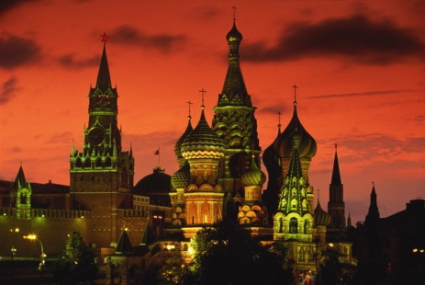
- Financial conditions
Participation in one event - 20 Euros
in two events - 30 Euros
Team - 50 Euros
Meals will be available during the tournament (a dinner
consisting of soup, hot dish and salad) – depending on
the number of participants, about 8-10 Euros per person per day.

- Brief tour plan

On April, 14-15th - recommended date of arrival.
On April, 15th – 19-00 Delegates’ Meeting and Buffet.
On April, 16th – competitions 16-17, 18 +; excursion across evening Moscow with supper, only for seniors.
On April, 17th – competition for under 16 years, tournament party
On April, 18th - day off, excursion to see the basic sights of Moscow.
On April, 19th - day off, excursion to see the basic sights of Moscow, departure to St. Petersburg.
On April, 20-21th excursions in St. Petersburg, returning to Moscow
On April, 22nd – in the morning, arrival in Moscow or to airport in St Petersburg, and
departure.

More detail:

April 14 or 15 - recommended date of arrival

- Airport

In Moscow there is more than one international airport. We recommend you arrive to and depart from Sheremetyevo airport, but if you arrive at another airport we will meet you if you send us details.

The transfer from the airport to the hotel and its cost will depend on the number of people in your group and your arrival time. Please note that in Moscow there is a difficult situation with road traffic, therefore it is necessary to plan all travel in advance. Traffic jams will affect all transfers/travel, therefore you are advised to follow the recommendations of the organizers regarding travel.

** Pricing & Allocation of hotel accomodation will be carried out according to the quantity of visitors. Therefore we request that you advise us by December 15th the approximate number of people who will attend from each country and any special requests. We will then send you more details of accomodation
Cost of 3*hotel with breakfast 40-50 Euros per person per night. We can search for lower cost hotel accomodation in the same neighbourhood where possible if you request it.
The position of the hotel is a very important factor in the planning and smooth operation of our event as Moscow is a big city, total population 16 million.
A translator will be attached to each delegation throughout the event to help with all questions.

April 15th – 19-00 Pre-tournament meeting with buffet.
Heads of delegations and main coaches are invited to a Pre-tournament meeting with buffet ( 2-4 persons per delegation). Transfer from hotel to meeting venue and back will be provided.
On April, 16th
Each transfer from the hotel to the Sports Palace and back to hotel will be approximately 5 Euros per person, the final price to be given later depending on numbers. An evening walking tour of the centre of Moscow is planned, for sportsmen whose performances have finished. More details later.
Sale of alcohol in all shops in Moscow is forbidden after 22-00 and to persons younger than 18 years; in bars there is no time restriction. The public transport works till 01-30, taxis operate round the clock, trip cost in city center about 10 Euros.

April 17th
The tournament banquet will begin at 20-00. The exact menu will be given later, but is planned to be standard Russian and European cuisine, cold and hot snacks, hot dishes, a dessert. Drinks – juice, mineral water, Coca-Cola, beer, spirits. We would like each country to prepare a small performance for the banquet. Performance by a musical group and a disco are also planned.
April 18th
Visiting of the main sights of Moscow with professional guides (in English). Plan of excursion and cost we will advise later. Automobile excursion across Moscow, after 22-00 in the evening.
April 19th
Continuation of sightseeing excursion across Moscow.
Trip to St Petersburg: For anybody interested in visiting St. Petersburg, the second-largest and important city of Russia, we will organize a trip to this city. St. Petersburg the former capital of the Russian empire, is 700 km from Moscow, very beautiful city with set of cultural and historical monuments.
Cost: ticket for high-speed train there and back 200 Euros, hotel 50 Euros, excursions and food at additional cost.
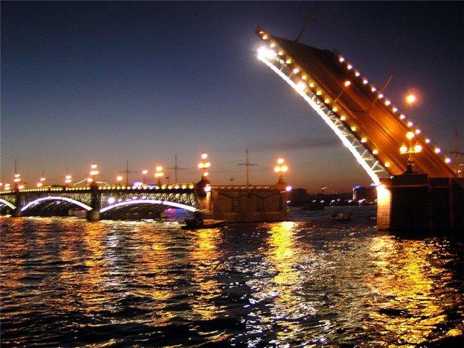
On April, 20-21th excursions in St. Petersburg, returning to Moscow or flying home from St Petersburg
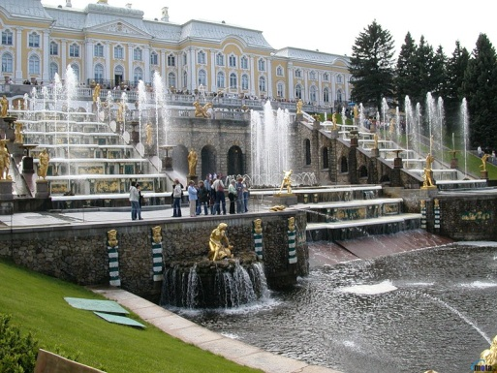

On April, 22nd Departure : It may be best not to return to Moscow if you visit St. Petersburg but to buy your return ticket from St Petersburg if you can. Otherwise, return to Moscow this morning to continue your homeward journey.
.We can offer the excursions shown. Please let us know if you are interested and want more information. If you are interested in any other excursion and want additional help we are ready to cooperate if you ask.

- Visa
A visa is required for most nationalities. Requirements for visas depend on the level of diplomatic relations between our countries.
You should enquire at the Consular department of the Embassy of Russia in your country for the particular requirements for your nationality. Then send us a list of the people in your delegation so that we can issue an invitation which you will probably need to be able to obtain a ‘Cultural’ visa.
For UK citizens, for example, the cost for a Cultural visa is £50 plus a charge for administration by an agent of approximately £25. However the cost appears to be about £30 in central Europe, possibly plus an agency fee.
It takes some time to acquire a visa, possibly 7 to 20 days. It can be a complex process so please contact us if you need assistance.

Our organization hopes for the active participation of all Kofukan International members at the World Cup of 2011 in Moscow. We are confident that a visit to our country will remain in the memory for a long time. In Russia, in Moscow, there are many interesting things to see and we hope that this trip will be pleasant for you.

Contacts
e-mail ruskofukan@nm.ru
tel. mob.
+7-903-6299279 the secretary of Federation Shito-ryu Kofukan Russia Irakly Sichinava
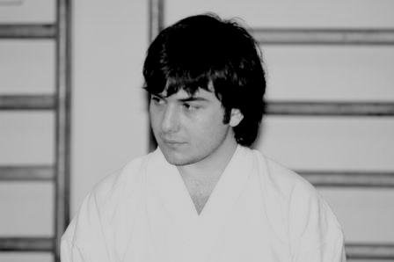

+7-916-5901716 Prezident of Federation Shito-ryu Kofukan Russia
Viacheslav Dubrovin
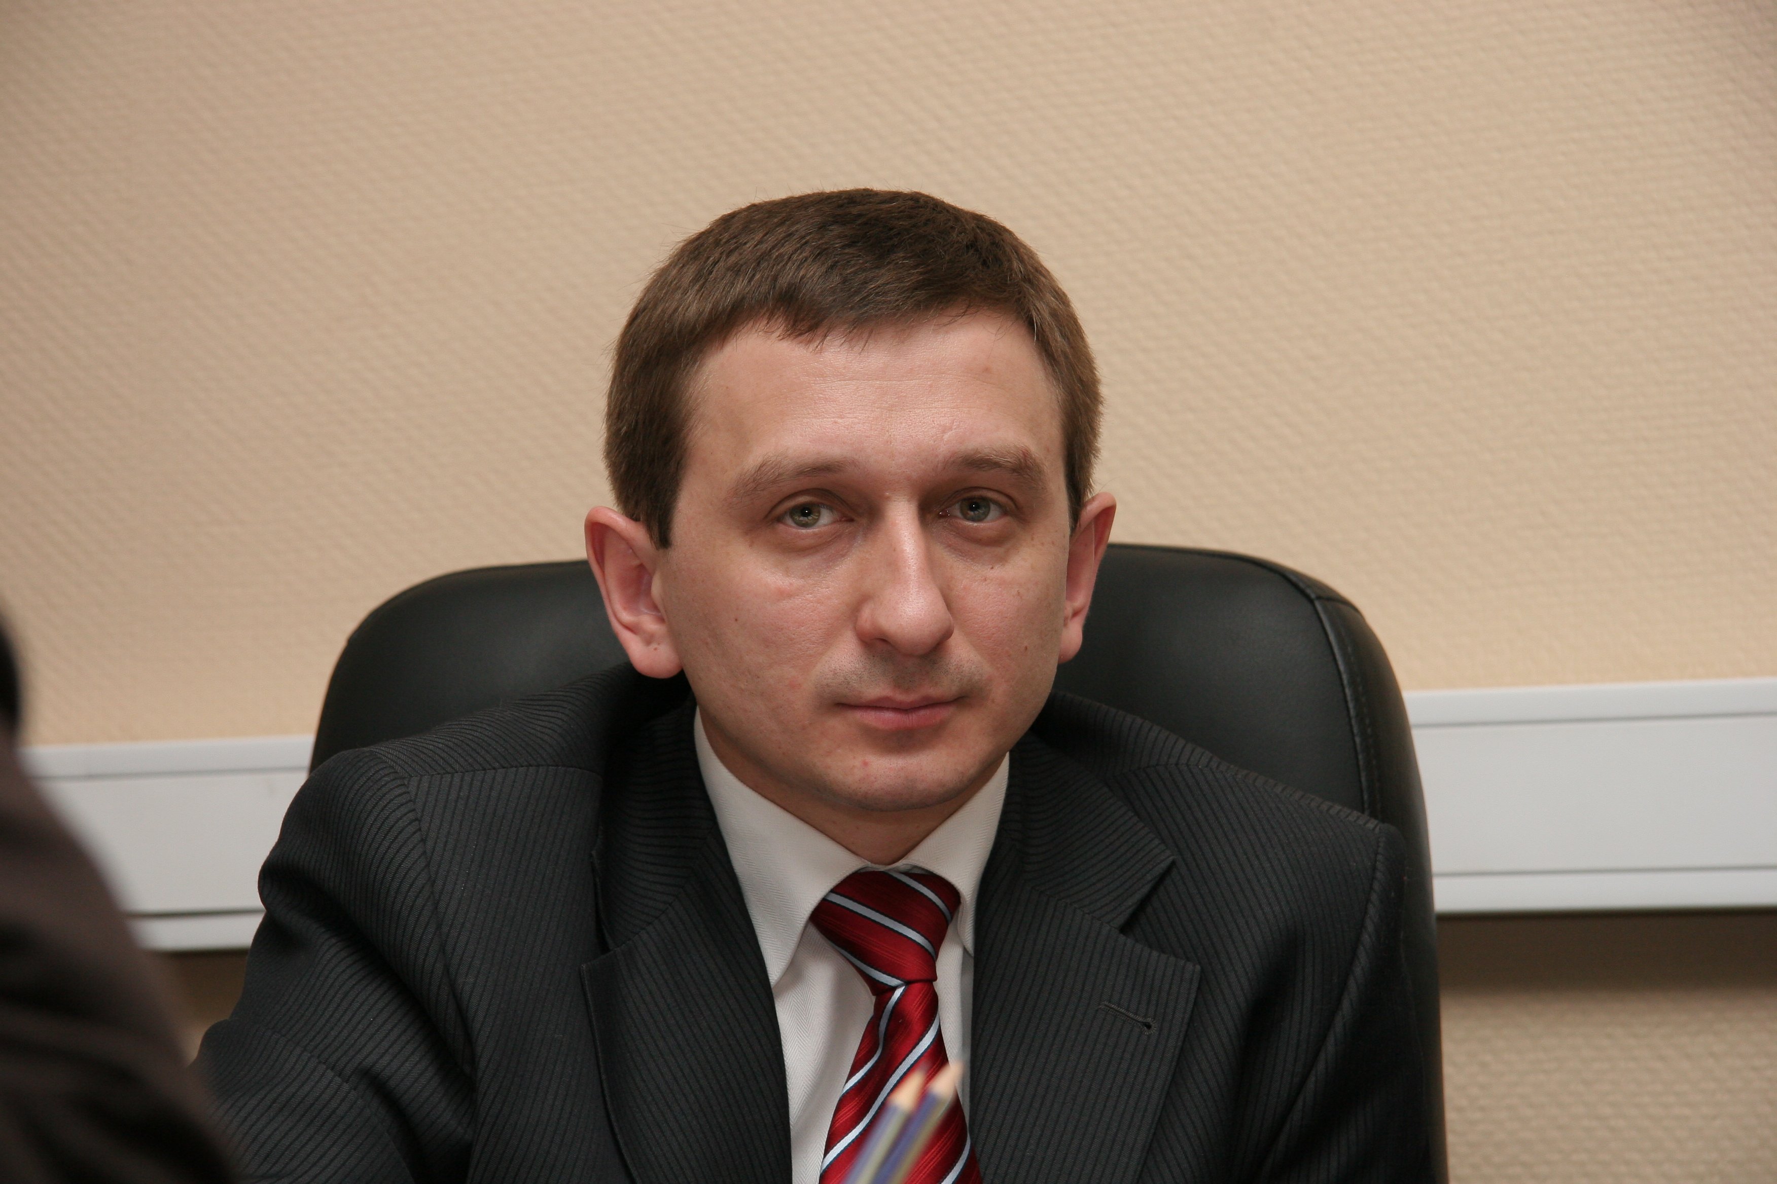
Phone/fax +7-495-7835178 or +7-495-783579

