

Next November 13th and 14th, the City of Imperia in Italy, and the FESIK (Federazione Sportiva Italiana Karate), will be hosting the 2nd WUKO World Cup for Clubs called “1st Memorial Carlo Henke”, for Children, Cadets, Juniors, Seniors and Masters (Veterans) categories (male and female). Participation is open to all clubs of the world.

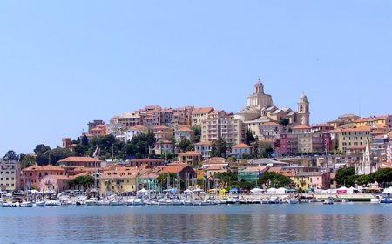

This event will be held in the Palasport of Imperia (Italy), a touristy city in front of the sea near the border between Italy and France. The Palasport of Imperia is completely new and located directly on the sea in San Lazzaro area.

INFORMATIONS:
WUKO Secretariat Office
Mail: wukosecretariat@wukokarate.org
Phone:(++39) 0323.71470
Fax: (++39) 0323.72444

PARTICIPATION FEES:
Children:
15 Euros for Kumite or Kata – 20 Euros for Kumite and Kata
Cadets, Juniors, Seniors & Masters:
20 Euros for Kumite or Kata – 25 Euros for Kumite and Kata
For more Categories add 10 Euros each
(exemple: cadets kata + kumite sanbon + kumite ippon > € 25 + 10 = Total € 35)

PAYMENT:
to WUKO World Union of Karate Do Organizations
Bank name: Banca Popolare di Vicenza, branch of Chiavari (GE) Italy
Code IBAN: IT91 T057 2831 9506 2957 0613 860
Code Swift: BPVIIT22629

PROGRAMM

FRIDAY 12th NOVEMBER 2010

AFTERNOON:
17.00 – 19.00: Check entry forms and payments
21.00: WUKO Congress

SATURDAY 13th NOVEMBER 2010

MORNING:
08.00 – 09.00: Check entry forms and payments
09.00: Kata Children A (6/7/8 years)
Kata Children B (9/10 years)
10.30: Kata Children C (11/12 years)
Kata Children D (13/14 years)

AFTERNOON:
14.00: Kumite Children A (6/7/8 years)
Kumite Children B (9/10 years)
Kumite Children C (11/12 years)
16.00: Open Ceremony
16.30: Kumite Children D (13/14 years)

SUNDAY 14th NOVEMBER 2010

MORNING:
08.00 – 09.00: Check entry forms and payments
09.00: Kata Cadets (15/16/17 years)
Kata Juniors (18/19/20 years)
10.30: Kata Seniors (21 to 35 years)
Kata Masters (36 years up)

AFTERNOON:
14.30: Kumite Cadets (15/16/17 years)
Kumite Juniors (18/19/20 years)
15.30: Kumite Seniors (21 to 35 years)
Kumite Masters (36 years up)
18.00: Closing Ceremony

Important : Please send the Entry Form to wukosecretariat@wukokarate.org or by fax ++39.0323.72444 before November 3rd, 2010 (deadline)

See you in Imperia, best regards!

